Launch one aws ec2 and install jenkins.
Steps:-
Install Jenkins on EC2 Instance
¹²³

Installing Jenkins on an Amazon EC2 instance involves setting up the server, installing required dependencies, and configuring Jenkins. Follow these steps to complete the process:
Step 1: Launch an EC2 Instance
- Log in to the AWS Management Console and navigate to the EC2 Dashboard.
- Click Launch Instance and select an Amazon Machine Image (AMI), such as Amazon Linux 2 or Ubuntu.
- Choose an instance type (e.g., t2.micro for free tier).
- Configure a security group: Allow inbound traffic on ports 22 (SSH) and 8080 (Jenkins).
- Create or select a key pair for SSH access.
- Launch the instance.
Step 2: Connect to the Instance
- Use SSH to connect to your EC2 instance:
ssh -i <your_key>.pem ec2-user@<instance_public_ip>

- Switch to root user:
sudo su -

Step 3: Install Jenkins
- Update the system packages:
sudo yum update -y # For Amazon Linux
sudo apt-get update -y # For Ubuntu

- Install Java (required for Jenkins):
sudo yum install java-17-amazon-corretto -y # Amazon Linux
sudo apt install openjdk-11-jre -y # Ubuntu

- Add the Jenkins repository:
sudo wget -O /etc/yum.repos.d/jenkins.repo https://pkg.jenkins.io/redhat-stable/jenkins.repo
sudo rpm --import https://pkg.jenkins.io/redhat-stable/jenkins.io.key

- Install Jenkins:
sudo yum install jenkins -y # Amazon Linux
sudo apt install jenkins -y # Ubuntu

- Enable and start Jenkins:
sudo systemctl enable jenkins
sudo systemctl start jenkins

Step 4: Access Jenkins
- Open a browser and navigate to http://<instance_public_ip>:8080.
- Retrieve the initial admin password:
sudo cat /var/lib/jenkins/secrets/initialAdminPassword

- Enter the password in the browser, install suggested plugins, and create an admin user.
Best Practices
- Regularly update Jenkins and plugins for security.
- Use IAM roles for secure access to AWS resources.
- Restrict security group rules to trusted IPs for SSH and HTTP access.
Jenkins is now ready for use on your EC2 instance!

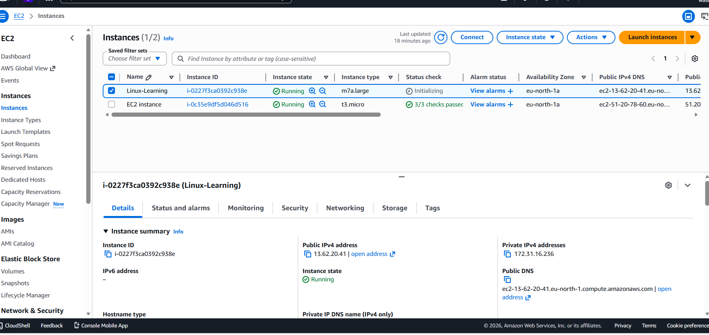

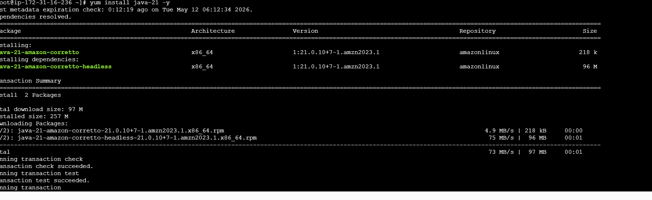

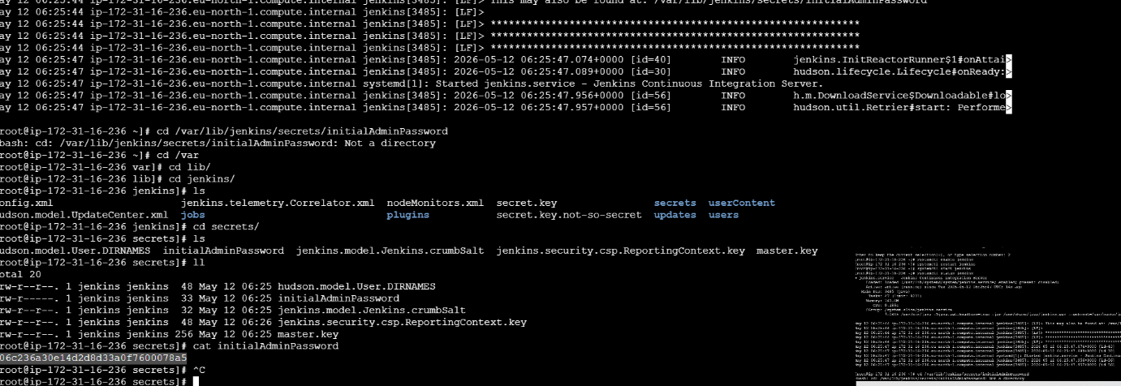

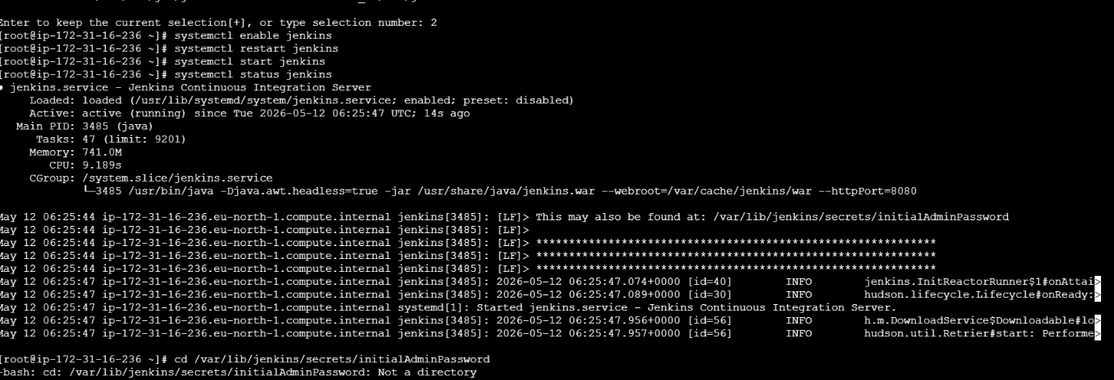

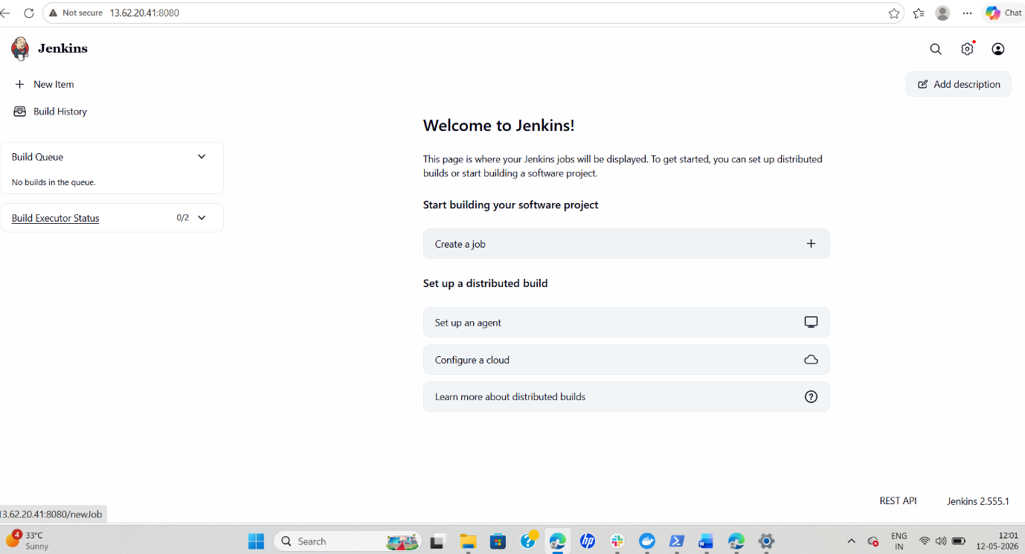

Setup Docker Desktop on your local windows.
- Open your browser and visit Docker Desktop Official Website
- Click Download for Windows to download Docker Desktop.
- Open the downloaded installer file (Docker Desktop Installer.exe).
- Keep the default options selected and click Install.
- Wait for the installation to complete, then restart your computer if prompted.
- Open Docker Desktop from the Start Menu after restart.
- On the welcome screen, click Skip or sign in with a Docker account.
- Open PowerShell and run docker --version to verify installation.
- Run docker run hello-world to test Docker successfully.

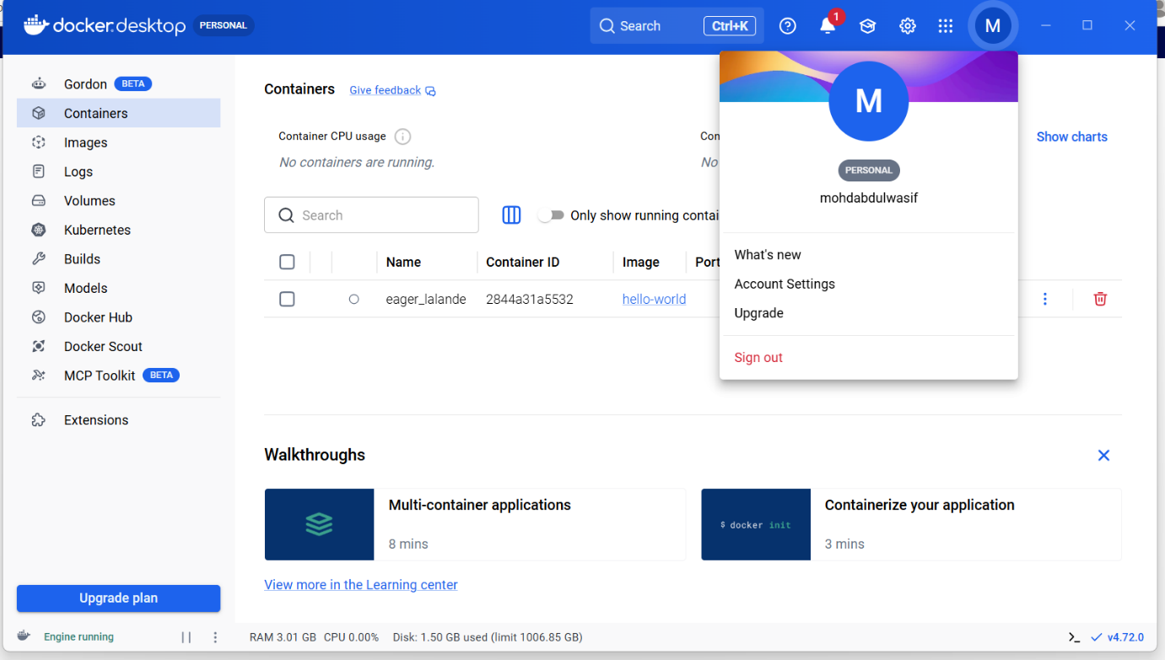

Setup Apache Tomcat on Ubuntu Virtual Machine
Open the Ubuntu Virtual Machine terminal and update packages using sudo apt update.
Install Java by running sudo apt install default-jdk -y.
Download Apache Tomcat from the official website: Apache Tomcat Official Website
Extract the downloaded Tomcat file using the tar command.
Move the Tomcat folder to /opt/tomcat directory.
Navigate to the Tomcat bin folder using cd /opt/tomcat/bin.
Give execute permission using chmod +x *.sh.
Start Tomcat server using ./startup.sh.
Open browser and verify Tomcat using http://localhost:8080.
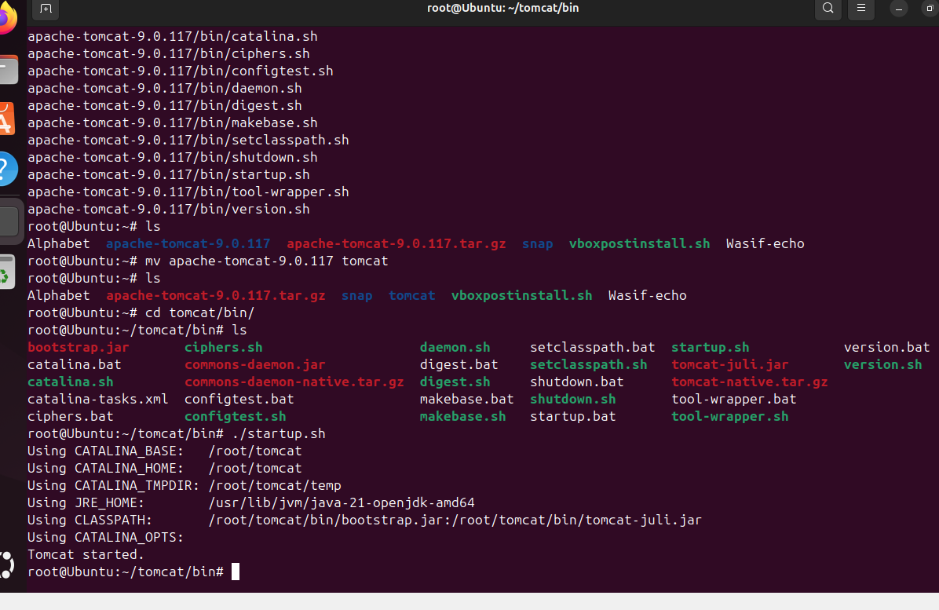
create a service file for Apache Tomcat.(Should execute by using systemtctl command) steps: download any sample war file check file by cd and cd webapps and wget sample file for tomcat then shutdown and start up cm -./shutdown.sh ./startup.sh
run on local host by typing localhost:8080/sample ,If you want to change html file open nano editor make a change (Wasif ) and save it ctr+y+enter key to save nano 